**SQL ASSIGNMENT 6**

Q1. Write an SQL query to print details of the workers who have joined in Feb 2014.

**Solution:**

Step-1. Select * from worker where date_of_joining between ’02-01-2014’ and ’02-28-2014’

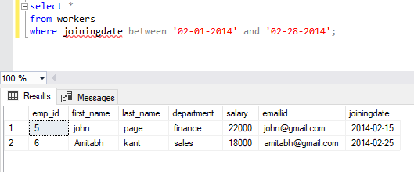

Q2. Write an SQL query to fetch duplicate records having matching data in some fields of the table.

**Solution:**

Step-2. Select first_name, last_name, Department, Count(*) as cont from worker Group by first_name,

Last_name, Department having Count(*)>1;

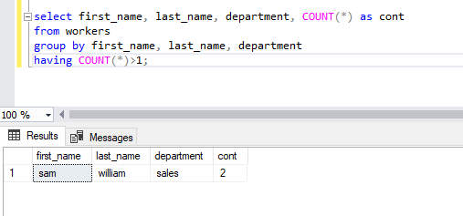

Q3. Write to remove duplicate rows from Employees table.

**Solution:**

Step-3. Delete from worker where emp_id not in ( select max(emp_id) from worker group by

First_name)

